Training & Cost Analysis

Rahul Kashyap

Founder & Freelance Data Analyst

Date:- 17-04-2025

**Introduction**

The **Training & Costing Analysis** project aims to provide insightful and data-driven evaluations of employee training programs within an organization. By analyzing training data alongside cost metrics, the goal is to uncover trends, measure training effectiveness, identify budget allocations, and highlight opportunities for optimization.

This project leverages **Power BI** to create interactive dashboards that visualize key performance indicators (KPIs), training participation rates, cost distributions, and departmental comparisons. These visualizations empower stakeholders to make informed decisions regarding future training investments and workforce development strategies.

Through this analysis, the project not only demonstrates technical proficiency in data visualization but also emphasizes how data can be transformed into meaningful business intelligence.

**Data Sources**

The data for this project was sourced from internal organizational records and includes details such as:

* **Employee Information**: Names, departments, and designations.
* **Training Programs**: Types, topics, and durations of training sessions.
* **Cost Data**: Training expenses per session, department-wise spending, and total budget allocation.
* **Participation Records**: Attendance and completion status of employees in various training sessions.

The dataset was primarily maintained in **Excel format** and imported into Power BI for modeling, transformation, and visualization.

**Objective**

The objective of the model is to analyze the training status on the basis of department head

Training Analysis:

* No of Training applied under each head
* No of training completed under each head
* Training result of each head
* No. of company Sponsored Trainings under each head (*Marks >=95 is CS*)
* Training applied for each module
* Percentage of self & company sponsored training

Cost Analysis:

* Department wise total salary
* Department wise cost of company sponsored training
* Bifurcation of company & self-sponsored training under each module
* Total no of trainings conducted under each module along with the total cost.

**Methodology**

To conduct the Training & Costing Analysis, the following steps were carried out using **Power BI**:

1. **Data Collection & Import**: Raw data from Excel sheets was imported into Power BI, including employee details, training records, and cost-related data.
2. **Data Cleaning & Transformation**:

* Null values and inconsistencies were identified and addressed using Power Query Editor.
* Data types were standardized (e.g., dates, numerical costs, categories).
* Relationships were created between tables to ensure a robust data model.

1. **Data Modeling**:

* Fact and dimension tables were structured for efficient slicing and filtering.
* Measures and calculated columns were created using DAX to calculate KPIs such as total cost, cost per employee, and average training hours.

1. **Visualization**:

* Interactive dashboards were designed using bar charts, pie charts, slicers, and tables.
* KPIs were displayed using cards and gauge charts for quick insights.
* Filters were applied for departments, designations, and training types to allow for deeper drill-downs.

1. **Insight Extraction**:

* Visual patterns and trends were observed and documented.
* Comparisons between departments and cost vs. outcome analysis were performed.

**Key Findings**

Some of the key insights derived from the analysis include:

* **Training Participation**:
  + The Sales and HR departments showed the highest training attendance.
  + Certain departments had lower engagement, indicating a need for improved awareness or relevance of training content.
* **Cost Analysis**:
  + A significant portion of the training budget was spent on external trainers.
  + Some training sessions showed high costs with low participation, suggesting a need for reassessment.
* **Performance Insights**:
  + Online training formats proved to be more cost-effective than in-person sessions.
  + Departments with higher training hours per employee generally had better performance metrics.
* **Optimization Opportunities**:
  + Consolidating similar training topics can reduce redundant costs.
  + Shifting some in-person sessions to virtual formats could further optimize budget utilization.

**Conclusion**

The Training & Costing Analysis project highlights the importance of aligning training initiatives with strategic workforce goals while maintaining cost efficiency. Through this Power BI-driven analysis, actionable insights were generated that reveal not just how much is being spent on training, but **how effectively** that investment is contributing to employee development and organizational performance.

The data revealed both strengths and areas for improvement, showcasing departments with high engagement as well as those that require attention. By linking cost data with participation and performance, this project delivers a comprehensive overview that aids in future planning and informed decision-making.

**Recommendations**

Based on the findings, the following steps are recommended:

* **Reassess Low-Value Training Programs**: Evaluate programs with high cost but low participation or impact and consider replacing or redesigning them.
* **Promote Online Training**: Expand the use of online modules to reduce costs while maintaining accessibility.
* **Optimize Budget Allocation**: Focus funding on departments with high training ROI and reduce expenses on redundant or underperforming sessions.
* **Increase Awareness**: Conduct internal surveys or campaigns to boost awareness and relevance of training opportunities, especially in under-engaged departments.
* **Monitor Regularly**: Implement a continuous dashboard monitoring system to track training trends in real-time and adapt strategies dynamically.

**Visualizations**

1. **Dashboard 1: Training Analysis** 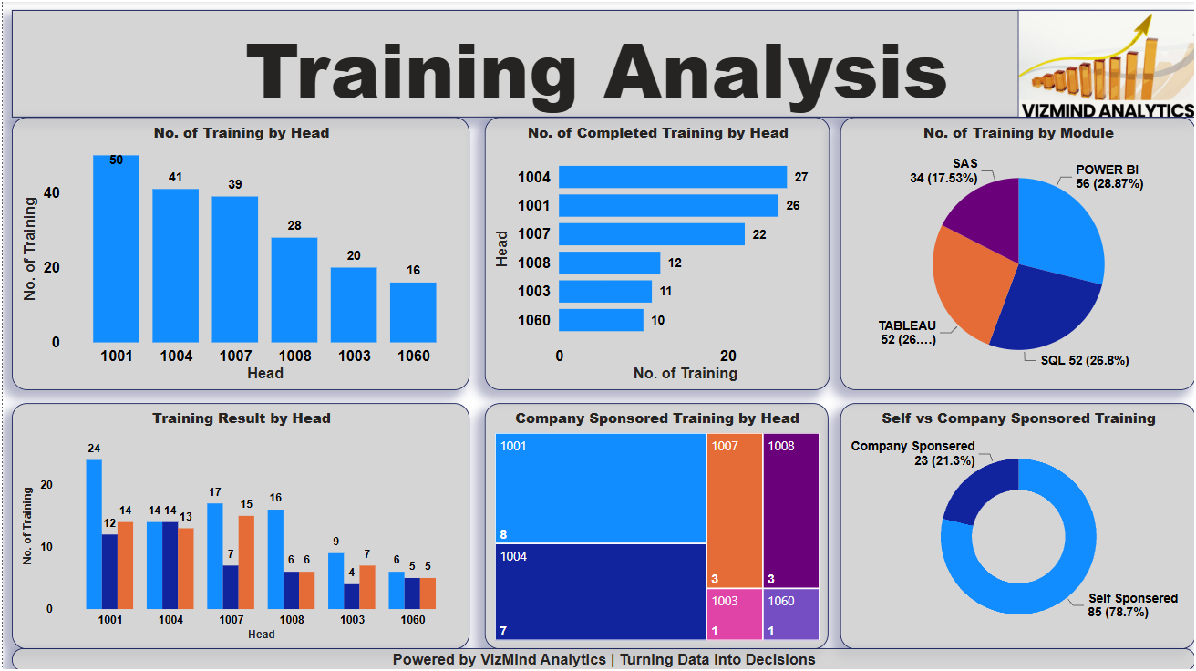
2. **Dashboard 2: Cost Analysis**

